Ideation Phase
Empathize & Discover
Date | 18 june 2026
Team ID
Project Name | HOUSE RENT
Maximum Marks | 4 Marks

Empathy Map Canvas:
An Empathy Map Canvas is a visual tool used to understand the needs, thoughts, feelings, and behaviors of users. It helps developers gain insights into user expectations and challenges, enabling the creation of solutions that provide a better user experience.
For the HouseHunt project, the empathy mapping process focused on understanding the needs of users searching for properties to buy or rent online. By analyzing user goals, frustrations, and decision-making behavior, the application was designed to provide an easy-to-use platform with efficient property discovery, secure authentication, detailed property information, and seamless communication with property owners.
The empathy map helped identify key user requirements such as easy property search, advanced filtering options, accurate property details, location-based browsing, and quick access to property inquiries. These insights guided the design and development of HouseHunt to ensure a simple, reliable, and user-friendly property-search experience.
Example:

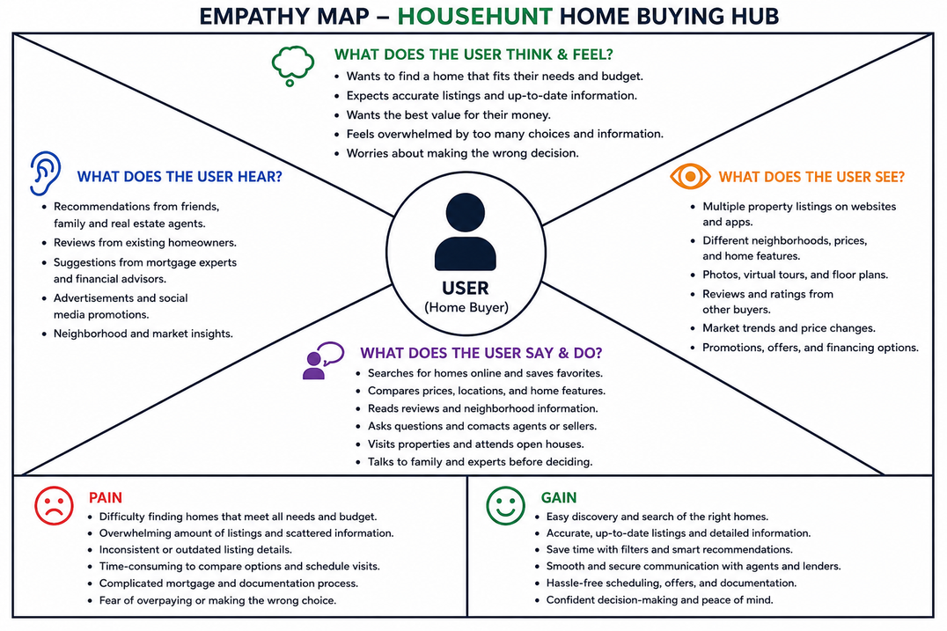

Reference: https://www.mural.co/templates/empathy-map-canvas

